CLOUDBURN DevOps Interview Questions
on October 04, 2018

Here is the List of Cloudburn Interviews Questions
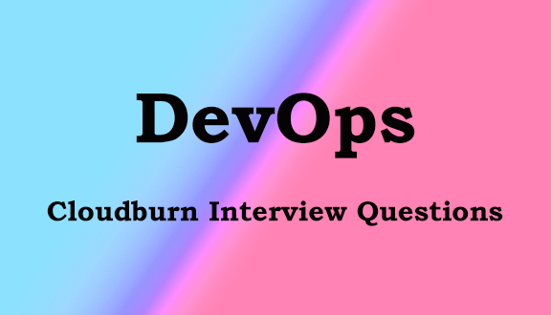

1.Tell me about u r self briefly

2. Roles and Responsibilities

3.How to create virtualhost in apache

4.Versions(like ansible, git, mysql,)

5. Write a playbook for installation of apache in ubuntu and centos

6. Document root of apache and tomcat

7. what is the configuration file in tomcat

8.Defaults port numbers(apache, tomcat, mysql)

9.How to connect client and server(windows to linux)

10.What is SSH

11.What is Docker file commands

12.How to create a link between two containers

13.How to port forward in dockerfile

14.Difference between small 'p' and capital 'P'(Docker)

15.How to create a job in Jenkins

16.What plugins are u used in your project

17.How to create a role in ansible

18.what are challenges you are faced

19. Are u faced performance issue

20.How to launch a instance from AWS

21.how to merge the code

22. How to write custom scripts in Maven

23.how to find a specific line in a file

24. Are u involved in ShellScripts

25. How to configure yaml file in vagrant file

